E-Shopper (An E-commerce App powered by GenAI and Django)

General Info:

1. What Is GenAI? What's Its Use Cases? [Generated by ChatGPT)

Ans:

Generative AI, short for Generative Artificial Intelligence, refers to a class of artificial intelligence techniques and models designed to generate content that is similar to what a human might produce. These models are used for various creative tasks, including text generation, image generation, and even music composition. Generative AI relies on deep learning architectures, such as Generative Adversarial Networks (GANs) and Recurrent Neural Networks (RNNs), to produce new data samples.

Some key applications of generative AI include:

1. **Text Generation**: Generative AI models like GPT (Generative Pre-trained Transformer) can generate human-like text, making them useful for chatbots, content creation, and language translation.

2. **Image Generation**: Models like Deep Convolutional GANs (DCGANs) can create realistic images, which have applications in art, design, and even generating synthetic images for training other AI models.

3. **Music Composition**: Generative AI can compose music, generating original compositions or imitating the style of a particular composer.

4. **Video Generation**: Some generative models can create video sequences, which can be useful for generating synthetic data for training computer vision models.

5. **Drug Discovery**: Generative AI can assist in discovering new drug compounds by generating molecular structures that have desired properties.

6. **Content Creation**: Generative AI can automate content creation for various media, from writing articles to generating artwork.

7. **Data Augmentation**: It's used to augment datasets for machine learning by generating additional synthetic data points.

Generative AI has made significant strides in recent years, leading to the creation of highly realistic and creative outputs. However, ethical concerns, such as deepfake generation and potential misuse, have also arisen alongside these advancements. Proper regulation and ethical considerations are essential when developing and deploying generative AI technologies.

2.What Is Meant by E-commerce Site?

E-commerce, short for "electronic commerce," refers to the buying and selling of goods and services over the internet, involving online transactions, digital payment processing, and the exchange of products or services without the need for physical presence at a brick-and-mortar location.

--------------------------------------------------------------------------------------------

Django-Ecommerce (E-Shopper) (An Ecommerce App build with Help of GenAI and Django and GenAI Guided resources)

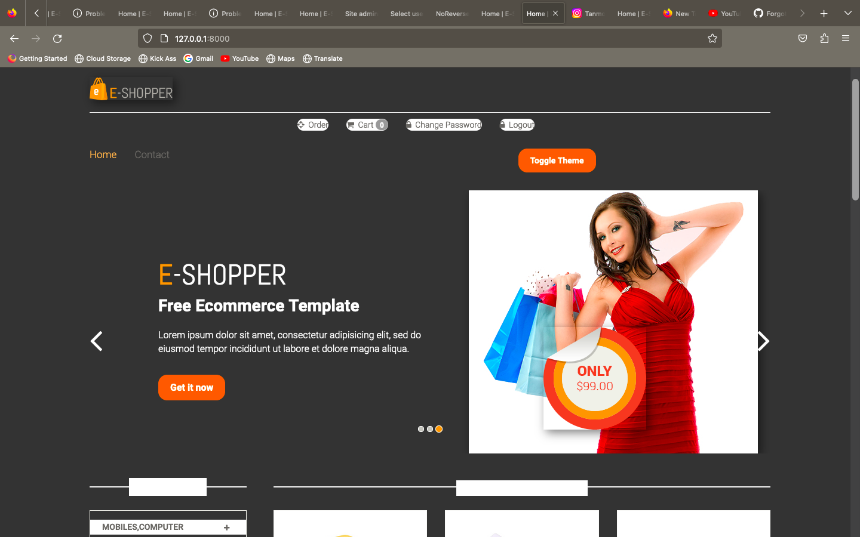

# User Manual (How To setup The Project On local)

1.Login to Your GitHub

2.Clone [Click here](https://github.com/Tan12345678/Django-Ecommerce.git)

3.You should download Python 3.5 + on your local

4.Open Your IDE (PyCharm/Vs Studio/etc.) Open Terminal And run

Git clone <Your copied link>

5. Go to **Django-Ecommerce** folder.

6.**Install requirements.txt**

7. Python manage.py runserver.

---------------------------------------------------------------------------------------

Note: If you found Any Error regarding Pillow package then **upgrade your pip and reinstall.**

----------------------------------------------------------------------------------------

**Administrator** User Id/Pass:I.e. Django- Administrator login

## admin(id), / admin(pass)

---------------------------------------------------------------------------------

Feature (Fully dev purpose)

1.User creation

2.Login with OTP and User Id and Pass

3.Change and Forgot pass

4.Add to cart

5.Product image price and name

6.checkout and payment(dummy)

About Tech Stack Used (Django-A easy to use web framework powered by Python)

I have used Django-built in functionality, libraries for this site

For OTP I have used Django-smtp-server you will receive OTP in mail

Credits:

1.ChatGPT (Powerful GenAI )

2.Youtube Resources

3. For Template I have used Readymade Template for E-commerce and Django-shopping-cart library for cart facility.

I will release the new version and updates in this project On GitHub. Stay Tuned.

So “"Unlocking the power of language, one conversation at a time."

by—ChatGPT

Thankyou (Tanmoy Malakar)

-------------------------------------------------------------------------------